 | The Rooster Crows  A Newsletter of the  Catholic Cursillo of the Diocese of Knoxville In Tennessee  Winter 2002 Volume 5 Number 2
"Follow confidently the way of formation and Christian life that you have Undertaken with so much Generosity "
Pope John Paul II to the Cursillo Movement May 6, 2002

In This Issue
¡Bienvenidos! 1
Secretariat Election Results 1
e-vangelization 2
Spanish Speaking Weekend! 2

Region IV Fall Encounter 2

A New Insight 3

Go, But Leave the Calculator Behind 3

National Encounter 2002 4

Pray First, Last, Always 4

Bible Puzzle Solved! 4

Ultreya Attendance 5

Hmmmm 5
First Ecumenical Ultreya in

Tennessee Held in Crossville 5

Time, Talent and Treasure 6
The School of Leaders 7

Cursillo in The East Tennessee Catholic 7
A Bible Riddle 7

Cursillo #16 8
Cursillo #17 9
2003 Calendar 10
Catholic Cursillo Application 11
The Secretariat 12

¡Bienvenidos!
Welcome to the Winter 2002 edition of The Rooster Crows. As we reported in the last edition, after a few years “roost-full” retirement, the rooster crows again! During a recent meeting of the Secretariat, we decided how often the roosted will be crowing – twice a year. The plan is to send out an issue right after our Spring/Summer weekends (July-ish), and then after our Fall/Winter weekends (December-ish). Initially we will be mailing copies to everyone, with the hope of moving to e-mail and web-based distribution. Please see the article e-vangelization for more information.
Inside this edition you will find a lot of great articles and information. I would like to call your attention to two items in particular: our 2003 Calendar of Events and the Catholic Cursillo – Diocese of Knoxville Application. The calendar would make a great addition to your refrigerator, and if you were to keep a copy of the application with it you would always have one at your fingertips. You may also want to place a copy of the calendar in your prayer book to serve as a visual prompt to remember our School of Leaders, Weekends and other events in your prayers.
Many of you may not have received the June 2002 edition of The Rooster Crows. We tried to e-mail it to as many of you as possible, but met with limited success. We then tried to send a copy out by snail-mail, but again we probably didn’t reach everyone. Should you be one of the folks we missed, please let us know and we will get a copy off to you either by e-mail or the USPS. Please contact Butch Feldhaus at bfeldhaus@csi.com for more information.

Secretariat Election Results
During the November meeting of the Secretariat, the positions of Treasurer and Secretary were up for appointment. We are pleased to report that Debbie Ferrari will continue as our Treasurer and Marianne Hartman will continue to serve as our Secretary.
Next October (10/4) the positions of Cursillo (Three Day Weekend), School of Leaders and Post Cursillo will be up for appointment. Currently Carol Bolton, Jim Heath and Susan Passarello fill these positions respectively, all of who have indicated they will not seek reappointment. If you are interested please let us know! The coming year would be a good opportunity to “shadow” them to see what all is involved.

e-vangelization
Just about every way of communicating or conducting business has been bestowed the prefix of “e-“ to indicate that the Internet has been utilized as another option for transferring information. e-vangelization, or spreading the Word electronically is the latest addition.
The Catholic Cursillo of the Diocese of Knoxville will be taking up residence along the information superhighway at www.knoxvillecursillo.org. We hope to have our website in operation in the Spring of next year. We intend to keep the design simple and informative. Information about the School of Leaders, Ultreyas, Weekends, announcements, applications and a host of other information will be available. We will not post names or other personal information.
We will also try to start moving all our mailings from the very expensive USPS “snail-mail” to the much less expensive and faster e-mail. Right now it cost several hundred dollars to make copies and apply the postage any time we conduct a mass mailing. Every newsletter sent by e-mail rather than snail-mail is a savings of at least $3.00 per person!
Key to making our e-mail venture work will be the Adobe Acrobat Reader. This free software is available from the website www.adobe.com. Many of you already have it, and for those of you who don’t it is easy to download and install. All you have to do is go to the Adobe website and “Get Acrobat Reader.” You will be prompted for what type of system you have, etc., and then the download will begin. When the download is complete, the application installs in minutes.

Spanish Speaking Weekend!
During the November 2002 meeting of the Secretariat, a target timeframe of Fall 2004 was set for our first all Spanish weekend. While this may seem a long way off, it will be here before you know it! To meet the challenge of presenting a weekend in Spanish, many resources will be required.
To provide a little clarification, many Dioceses or Cursillo Centers have parallel Cursillo organizations based on language. For example, there may be an English element with its own School of Leaders, Secretariat, etc., and then the same setup for a Spanish element and possibly a Vietnamese element. We felt this type of structure would dilute an already small movement, so for now our approach is to remain the Catholic Cursillo of the Diocese of Knoxville in Tennessee, which happens to have weekends in English and Spanish and (?).

Region IV Fall Encounter
By Butch Feldhaus
In late October, I attended the Region IV Fall Encounter in Little Rock, AR. It was held at the St. John Pastoral Center, the former St. John Seminary, which had been converted into an office complex for the Diocese of Little Rock. On site there were excellent facilities for retreats and conferences. The rooms we stayed in were private, clean, quiet and comfortable. The conference center had ample space for our large group meetings and worship services. This facility is used to host the Cursillo weekends for the Diocese of Little Rock, and the Cursillo has an office in the complex, which is staffed during regular business hours.
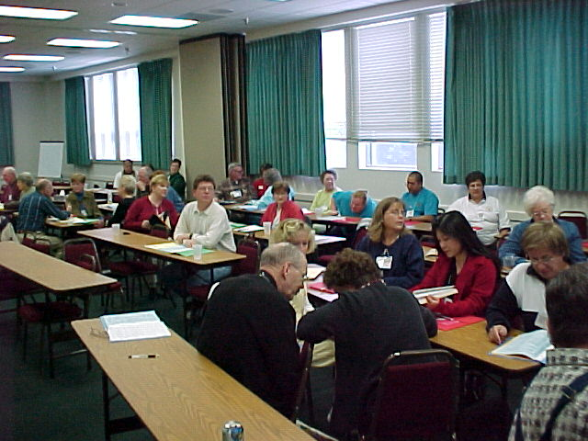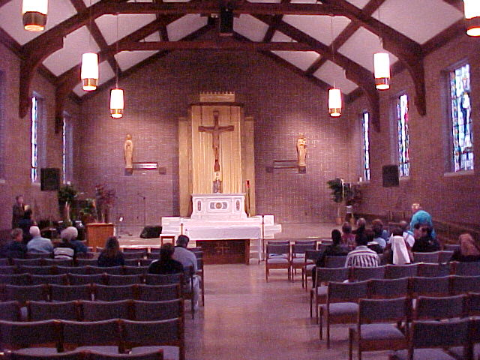
The theme of the weekend was “Letting the Light of Christ Shine.” The format was much the same as the Cursillo weekend; a talk followed by small group discussion and time for private reflection. We also met for Morning and Evening prayer, Mass and Ultreya. The similarity ends there, as the pace of the Fall Encounter was much more relaxed and the atmosphere was much more of a family and Spiritual homecoming.
The Spanish-speaking element of the Little Rock Diocese was also with us, but they met separately for most of their talks and discussion. We did get together for a Bi-Lingual Mass, which was a real treat.
There were three main talks on the weekend; Christ, Our Light by Fr. Al Wilson, Growing As Light by Becky Guenthner, and A Community of Light, also by Becky. There were two workshops; Living as Light and Sharing the Light, conducted by members of the Regional Service Team. All were excellent, and very Spiritually refreshing.
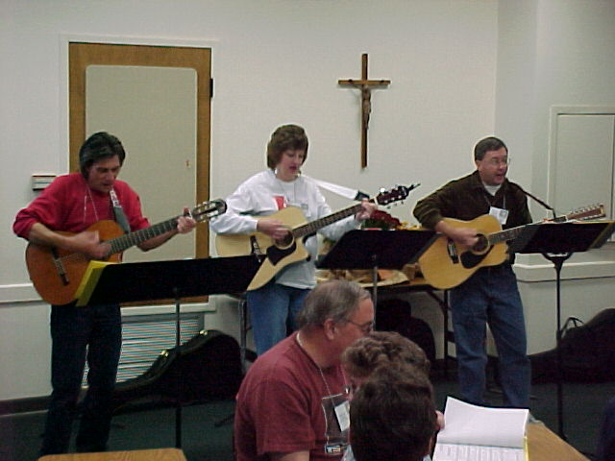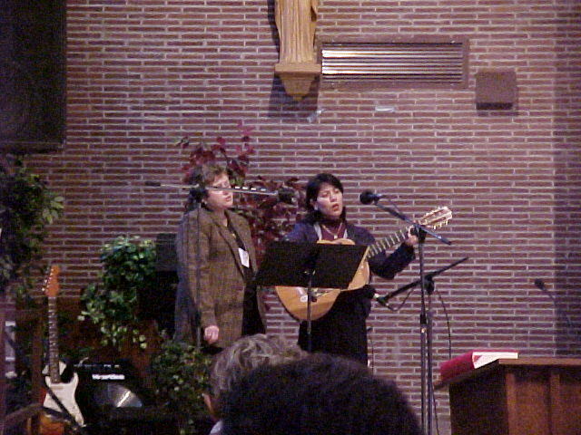
The Roamin’ Catholics and members of the Spanish Speaking Cursillo lead us in sung worship.
The Region IV Fall Encounter is open to everyone, and I would encourage you to consider attending. Next year it will be held October 24-26 at Our Lady of the Snows in Bellview, IL. Bellview is just East of St. Louis, MO.
A New Insight
By Marianne Hartman
As a result of attending the Cursillo Movement's 12th National Encounter in Louisville, KY this past July, I received new insights into several phases of our movement. One of the major goals Cursillo has set for itself is to have a positive influence on our environment. On Friday for the major address, Teresa Tomeo presented "Effecting the Media Environment, We can Make A Change". Teresa is a professional speaker, media consultant and broadcast-journalist from Detroit, MI, and currently hosts a daily talk show on Christian radio.
Teresa challenged each of us to use our "Power of One" to affect the quality of TV, CD's, the Internet, songs and talk shows on the radio, even the choice of magazines available in our school libraries. Every facet of the media influences our children and us! Sex and violence have become an accepted way of life, mainly because we see it on TV and the Internet, hear it on radio and CD's and magazine ads use it to appeal to the consumer.
A few statistics cited were:
- 75% of what is seen and heard encourages irresponsibility
- 3 out of 4 teenagers say pre-marital sex is OK
- TV in the bedroom encourages obesity
- 50% of what is seen on MTV encourages violence
- The average age of the viewer of pornography on the Internet is between 12 and 17 years old
Some of the ways we can bring about a change are:
- Write a letter to a local TV or radio station to protest a program we find objectionable. Every letter received represents 1000 listeners.
- Make a phone call to the program director or manager expressing our complaint.
- Let the sponsors of the program know we will no longer purchase their products.
Teresa has compiled a "Family Media Guide" that gives information on who to contact at the TV networks, helpful organizations and their web sites, suggestions for developing healthy media habits, internet filters, and how to deal with the media and alternative news sources. All this and more can be found by going to her web-site www.teresatomeo.com . It will be well worth your time.
"In the face of so many enemies it is not possible for us to sit with our hands folded." St. Terese of Avila

Go, But Leave the Calculator Behind!
By Butch Feldhaus
In the December 8, 2002 edition, the Chattanooga Times Free Press ran an article by staff writer Sean McCombs titled “Church Attendance Study Analyzed.” This article cited research done by the Glenmary Research Center in Nashville, TN, indicating that the average church attendance in Tennessee is 51.1%. The article focused on Rhea County, which in spite of the John Scopes trial and some who considers Dayton, TN, to be the “center of Fundamentalism,” the average attendance was only 45.4%. Bledsoe County was listed as having the lowest at 32.7%. The following summary was presented in the article. The Glenmary Research Center was cited as its source.

Church Numbers
Hamilton County 58.2%
Bradley County 57%
Rhea County 45.4%
Meigs County 44.7%
Sequatchie County 41.6%
Marion County 35.9%
Bledsoe County 32.7%
Tennessee Average 51.1%
As I reflected on the article and the averages, I came to the conclusion that this may be a less than optimal way of looking at the church. To me, the focus seems to be that of a Field Of Dreams – we have built churches and they will attend, we have the averages to prove it. When we read about the early church in scripture, we are rarely provided with counts, generally we read words similar to “many believers were added” or “the church grew steadily in number.” Perhaps this is a better focus – the early leaders of our church seem more interested in telling us about casting the net, rather than counting (or averaging) the numbers of believers they hauled in.
When we celebrated the Ascension of the Lord last May, our Gospel reading from Matthew (28:16-20) quoted Christ as saying “Go, therefore, and make disciples of all nations, baptizing them in the name of the Father, and of the Son, and of the Holy Spirit, teaching them to observe all that I have commanded you. And behold I am with you always, until the end of the age.” Taking some liberty with this passage I would like to suggest the following might be our focus “Go, therefore, and evangelize your environments. Make friends. Be a friend. Bring your friends to Christ. And behold I am with you always in your Holiness, Formation and Spiritual Direction.” Paraphrasing Mother Teresa “We are not called to be successful, only faithful.”
Go, therefore, and leave your report forms and calculators at home.

National Encounter 2002
By Carol Bolton

On July 14, Butch and Mary Beth Feldhaus, Marianne Hartman and I traveled to the 12th National Cursillo Encounter at Bellarmine University in Louisville, Kentucky. Smiles, camaraderie and helpful people greeted us.
After finding our dorms and assigned rooms, we proceeded to dinner and shared meals with other Cursillistas. Our group shared one meal with Jorge Barcelo, the National Spanish-speaking Coordinator and talked about what our diocese could do to start a Spanish-speaking Cursillo.
At the gathering in the Field House we learned that this Encounter would be translated in both English and Spanish via individual headsets for the first time.
Friday began like most weekends--- early...at 6:30 for breakfast and as on Cursillo Weekends there was no lack good food.
The major presentation followed morning prayers. The keynote speaker was Teresa Tomeo, a broadcast-journalist with 20 years experience in the Detroit radio and TV market. She currently is a professional speaker and media consultant and hosts a daily talk show on a Christian radio station in Detroit. She provided valuable instructions on how to positively influence today’s media.
Each day we celebrated Eucharist together and it was soul-stirring for me to see the procession and recession of many priests, deacons, several bishops and the Archbishop from Louisville. A count after a Mass revealed 758 years of priesthood present and concelebrating.
On Friday each of us attended a different Workshop, mine was on the 3 Days. One of the interesting topics for me was about how our weekend schedule can help the candidates understand the message of the 3rd Day. On Friday Bishop Roman of Miami did a major presentation on Social Justice.
Saturday we were divided into groups according to our last names and we participated in a Synod. I must admit the title and idea scared me! There were 6 areas for discussion and there were sessions in English and Spanish. We started as a large group of 30 to 40 and then divided into groups of 10 to 15 and discussed given information, then we divided into 2’s and then reversed the procedure, finally presenting the main points of the group discussion to the large group. Ultimately the information will be used by National to develop diocesan Pastoral Plans.
We attended a Fiesta Saturday evening and really enjoyed celebrating. The highlight of the evening was the informal songs, learning Spanish songs, singing by a group of priests and Teresa Tomeo teaching the priests the Macarena.
It felt so good to be part of such a wonderful happy group and if you can, plan to attend next years Encounter. It will be held on July 17 to 21 in Cincinnati. Any Cursillista is welcome, so make plans now. This will be the last year for a while that it is held in the Midwest. It is a heartwarming experience!

Pray First, Last, Always
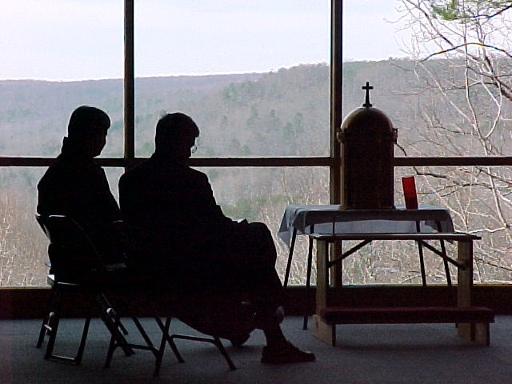

Fr. Alex and Fr. Brando spend time in prayer before the Blessed Sacrament just prior to a presentation given by Fr. Brando during a recent weekend at Camp Lookout on Lookout Mountain. (Photo by Butch Feldhaus)

Bible Puzzle Solved!
By Butch Feldhaus
Did you find the names of 16 books from the Bible in the paragraph below without the aid of your bible?

Mark Luke Revelation Numbers
Acts Judges Hebrews Lamentations
Job Titus Ruth Kings
Esther Peter James Amos

I once made the remark about the hidden books of the Bible. It was a lulu; kept people looking so hard for facts... and for others it was a revelation. Some were in a jam, especially since the names of the books were not capitalized. But the truth finally struck home to numbers of our readers. To others it was a real job. We want it to be a most fascinating few moments for you. Yes, there will be some really easy ones to spot. Others may require judges to help them. I will quickly admit it usually takes a minister to find one of them, and there will be loud lamentations when it is found. A little lady says she brews a cup of tea so she can concentrate better. See how well you can compete. Relax now, for there really are sixteen names of books of the Bible in this paragraph.

Ultreya Attendance
By Jim and Sue Heath
What is your Ultreya group doing to increase the attendance at your Ultreya? We have been having great success in getting a high percentage of our Cursillistas to participate at St. Alphonsus in Crossville. Maybe some of the things we are doing could be used by your group to increase your attendance.
About one week before our regularly scheduled Ultreyas, one of our members has the responsibility to send an e-mail notice to all the Cursillistas for whom we have e-mail addresses. We mention the time, place, witness & anything special that is going to happen. Another member has the responsibility for calling the ones who do not have e-mails. We always suggest that they mark it on their calendar in red.
Another thing we have been doing is we pass around a sheet which shows who has volunteered to be moderator, witness speaker, song leader, bring snacks and will be saying the closing prayer, when we visit the Blessed Sacrament. As they see the various people who have volunteered they are encouraged to step and accept some of the shared leadership. While we still have to ask people to do specific duties from time to time, we are getting a greater participation and keeping up our attendance.
We pray that we will be able to continue our success and that you will be able to use some of the above to do the same

Hmmmm
By Susan Passarello
Commitment sheet, commitment sheet…………..hmmm I know I have that somewhere. Mine is in my wallet stuck between an extra blank check and a receipt I know I’ll never need. Occasionally I will get it out and look at it. I have to say I am still fulfilling the commitments I made in 1998. I am not doing some at the same frequency I originally committed to, but all in all I think I’m doing o.k. I would urge you to find your commitment sheet and periodically evaluate where you stand on fulfilling those commitments. A large part of our Fourth Day is following through with the commitments we made on our weekend. Christ is still counting on you. Of course Ultreya is one area you may want to evaluate in your Fourth Day. We have now settled on a schedule for the diocese. Thank you for you patience.
- St. Jude (Chattanooga) Third Friday of the Month 7pm
- St. Therese (Cleveland) Second Wednesday of the Month 6:30pm
- St. Alphonsus( Crossville) Second Tuesday of the Month 7pm Central Time
- Sacred Heart (Knoxville) Fourth Friday of the Month 7pm
- Our Lady of Fatima (Alcoa) Second Thursday of the Month 7pm

As always, if you have any questions or comments please let me know.
Susan Passarello
qpass@aol.com
865 531-6251

First Ecumenical Ultreya in Tennessee Held in Crossville
By Carol A. Rummel
On Sunday afternoon, July 28th, the Holy Spirit brought five Christian groups together in fellowship and praise. St. Alphonsus Catholic Church on Sparta drive hosted the first ecumenical ‘Ultreya’ in the state of Tennessee and perhaps in the United States. Approximately 65-70 Christians from several faith traditions gathered in the social hall of St. Alphonsus to share their love of Christ with one another.
Father Patrick Brownell, pastor of St. Alphonsus Catholic Church welcomed the attendees to what he hoped would be an on-going dialogue of sharing.
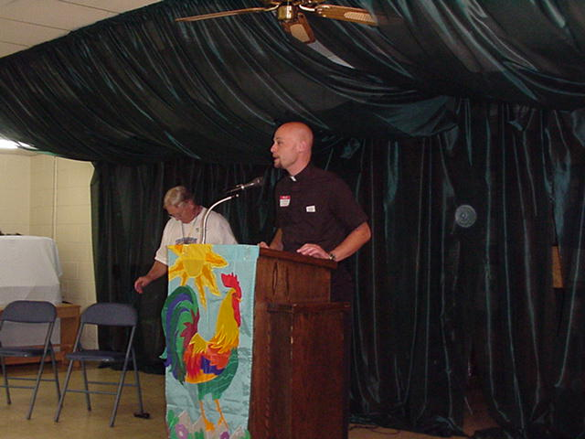
Five Christian faith traditions were represented at this ‘Grand Ultreya’: Methodist, Lutheran, Baptist, Episcopal, and Catholic. Each man and woman present respecting the faith traditions of the others while knowing their love of Christ is central to their beliefs. They shared songs of praise, life-changing moments, prayer and light refreshments. Deacon Joe Solis of St. Alphonsus closed the program with a prayer of thanksgiving. All the participants enjoyed the afternoon and plans were made for another ecumenical ‘Ultreya’ to take place in the fall to be hosted by Holly Neal and the Walk to Emmaus group.
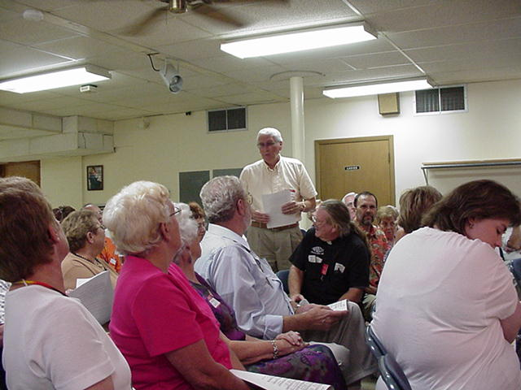
As I walked among the gathering, people were heard to remark, “This is wonderful!”, “You can see God is working in our lives here in Crossville” and “This is just the beginning!”. The general atmosphere was joyful and smiles were in abundance. When the two hour gathering was over, new friendships were in place.
In what appeared on the surface to be a chance encounter at the golf course, an idea took hold and began to form. Sue Heath, a Catholic from St. Alphonsus and Peggy Nicolas from the Lutheran Church at Fairfield Glade realized they both had something more in common than golf. They both had had a personal encounter with Christ on a weekend known as a Cursillo. This “chance” meeting was the beginning of an ecumenical gathering among five different Christian churches here in Crossville. The Holy Spirit is definitely present in Crossville!
Once the idea took hold, others began to get excited about it and work toward their joint goal. Instrumental in making this afternoon happen were also Holly Neal from First Methodist Church, with the Walk to Emmaus group, Ken Deadmon from the Non-denominational Church in Lake Tansi, with Tres Dios and Irene Wired from St. Raphael Episcopal Church. Monica Mowdy from First Methodist Church contributed her talents on the guitar to provide music for the afternoon gathering.
Fr. George P. Landry traveled from Sparta to take part in this historic event. Fr. Landry works primarily with the Kairos program, which is the movement’s prison ministry.
Cursillo (pronounced kur-see-yo) is a Spanish word meaning short course. The Cursillo movement began in Spain and spread to the United States primarily in the Hispanic Communities at first and then throughout the Christian denominations with each group adapting their own name. The Catholics refer to this encounter weekend as Cursillo, while the Lutherans call theirs Via de Christo. The Methodists have the ‘Walk to Emmaus’, the ‘Tres Dios’ group is non-denominational, and the Episcopal Church follows the Cursillo (almost identical to the Catholics).
These encounter weekends usually begin on Thursday evening and end the following Sunday afternoon. During the three days, those attending live and work together listening to talks given by clergy and laity. They also share Eucharist, prayer and fellowship. The titles of the talks for the Catholic Cursillo indicate their content: Ideal, Grace, Laity, Faith, Holiness, Formation, the Sacraments, Evangelization, Obstacles to Grace, Leaders, Evangelization of the Environment, Christian Life, Christian Community, and Group Reunion. The other groups have similar talks with different titles. Each talk is followed by a discussion period. According to the National Cursillo Center pamphlet, the goal of the movement is that Christ be the prime influence in society. So it is said that the primary objectives of the Cursillo Movement are to develop in adult Christians a consciousness of their power and mission to become leaders in the work of Christian renewal, and to sustain them as they provide a Christian leaven in civic, social and economic life. This “Christianizing of environments” is what the Cursillo Movement is all about.

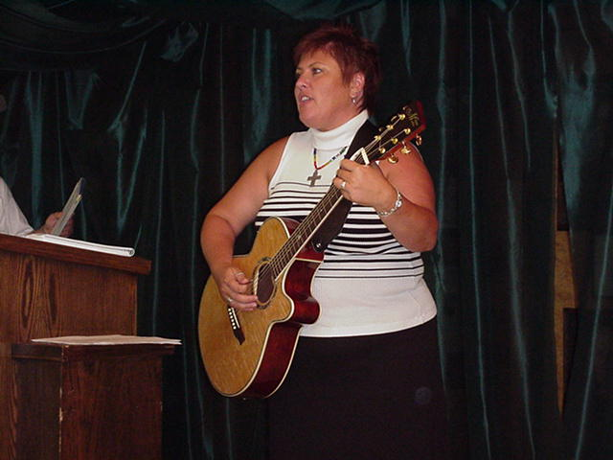
In the Cursillo Movement, the community spirit is continued after the three-day weekend through the Ultreya (which is Spanish for “onward”) or reunions of the community. These Ultreyas usually take place once a month as a means of growth, support, and enthusiasm within the community.
Anyone wishing more information about this Christian movement, may contact one of the following persons: Catholic Cursillo-Jim or Sue Heath, 788-2569; Methodist, Walk to Emmaus- Holly Neal, 788-6337; Lutheran, Via de Christo-Peggy Nicolas, 788-6103; Non-denominational, Tres Dios-Ken Deadmon, 788-2634; and Episcopal, Cursillo- Irene Wirer, 707-0142.
Time, Talent and Treasure
By Butch Feldhaus
Throughout the year we are fortunate to have many, many, volunteers who donate their time and talent to our movement. Currently these wonderful stewards of our movement fund nearly all the expenses associated with their activities from their own treasure. For the past five years the “financial focus” of our movement has been on meeting the needs of the three-day weekend and paying our dues to the National and Regional Cursillo organizations. We are currently working on a budgeting system to help cover the cost of the weekends and the two other major areas of the Cursillo, the Pre and Post Cursillo. We hope to have this in place by the Summer of 2003. Until this system is in place and we can more accurately project and hopefully fund these activities, any donations you might like to make to the Cursillo would be very helpful. Donations may be forwarded to our treasurer, Debbie Ferreri. Thanks in advance for your generosity!
Debra Ferreri
1321 Parker Ave. SW, Cleveland, TN 37322-2439
423/478-5619 bambilynn2@aol.com
The School Of Leaders
From the Cursillo Leaders' Manual, we learn that The School of Leaders is the Reunion and Ultreya of the leaders of the Cursillo Movement. It is the working arm of the Secretariat and provides a place for the continuing growth and understanding of the Church and the Movement, for those who have taken the success of the Cursillo Movement as their own responsibility.
Don't let the title "School of Leaders" fool you into thinking this may not be something for you. Once again, going to our Cursillo Leaders Manual, the School of Leaders is the English rendition of "escuela de dirigentes." While "escuela" is literally translated as school, it carries the connotation of leaders as a group, as well as the connotation of a gathering of these leaders on a regular basis. In the past, the School of Leaders was referred to as Leader's School, but was changed to School of Leaders to emphasize it as a gathering of leaders (think of a school of fish) rather than something like a Driving School - a place where people go to learn to drive. As Cursillistas, we are already leaders - the School of Leaders is where we gather to facilitate our growth.
Perhaps the following three questions will help you decide if you should attend:
- Are you seeking continual improvement in yourself?
- Are you seeking continual improvement in the Cursillo Movement?
- Are you seeking continual improvement in the environments in which you find yourself?
Did you answer "yes" to any or all of these? If you did, perhaps the School of Leaders is something you should seriously consider. You may have noticed that the following questions were not on the list:
- Are you a member of the Secretariat?
- Are you an Ultreya Leader?
- Are you on a team in formation for a weekend?
- Do you want to be a member of the Secretariat, a weekend team or an Ultreya leader?
While it would be very important for persons who might answer "yes" to these questions to attend the School of Leaders, it is not the primary reason.
For more information about the School of Leaders, you may want to review Chapter 6 of the Cursillo Leaders' Manual.
Cursillo in The East Tennessee Catholic
By Butch Feldhaus
In the December 8, 2002 edition of The East Tennessee Catholic Bishop Kurtz makes reference to The Evangelizing Parish presentation he made during our most recent School of Leaders meeting. The Bishops column can be found on the ETC website at http://www.etcatholic.com/dec8/bishop.htm. If you have a minute I recommend stopping by and reading (or re-reading) and reflecting on it. It is an excellent recap of his presentation.
While you are visiting The East Tennessee Catholic website, be sure to check out Dan Mc Williams excellent article about the Catholic Cursillo of the Diocese of Knoxville at http://www.etcatholic.com/feb10/cursillo.htm. You may also want to check out the article about the Ecumenical Ultreya (that also appears in this edition of The Rooster Crows), which can be found at http://www.etcatholic.com/aug11/ultreya.htm.

A Bible Riddle
Submitted by Butch Feldhaus

From the e-mails I got after last month’s Bible Puzzle I got the idea you enjoyed being stumped, so here’s another. I’ll publish the answer in the next issue.

The answer is one word, five letters long, and appears only four times in the King James Version of the Bible.

God made Adam out of dust, but thought it best to make me first; so I was made before the man according to the Lord's Holy Plan. My whole body God made complete, without arms or hands or feet. My ways and acts did the Lord control, but in my body He placed no soul. A living being I became, and Adam gave to me a name. Then from his presence I withdrew, for this man Adam I never knew. All my maker's laws I do obey, and from these laws I never stray. Thousand's of me go in fear, but seldom on the earth appear. Later, for a purpose the Lord did see, he placed a living soul in me. But that soul of mine the Lord had to claim, and from me took it back again. And when this soul from me had fled, I was the same as when first made; without arms, legs, feet, or soul, I travel on from pole to pole. My labors are from day to night, and to men I once furnished light. Thousands of people, both young and old, did by my death bright lights behold. No right nor wrong can I conceive, the bible and it's teachings I can't believe. The fear of death does not trouble me, pure happiness I will never see. Up in Heaven I can never go, nor in the grave or Hell below. So get your Bible and read with care, you'll find my name recorded there.

Preach the Gospel always, and if necessary, use words! St. Francis of Assisi

Diocese of Knoxville - Men's Cursillo #16
September 19 - 22, 2002 Camp Eagle Rock
Table of St. Paul | Table of St. Michael
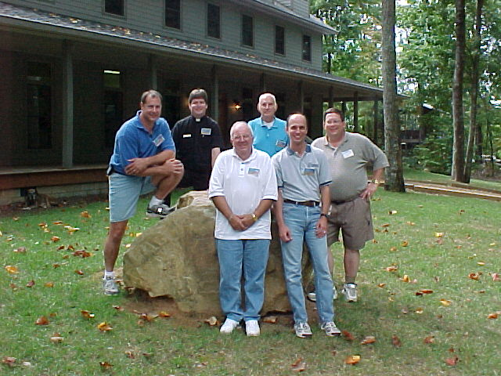 | 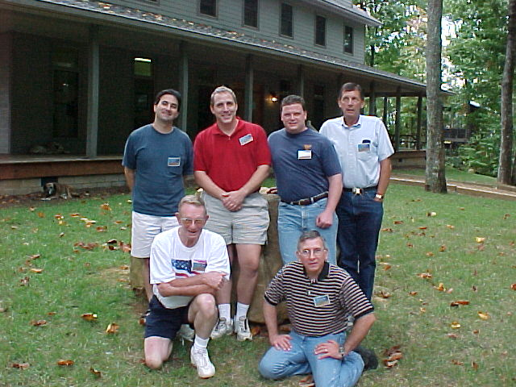
L→R Back Row: Joe Palladino, Fr. Alex Waraksa,  Joe Armento, Bob Klein. Front Row: Ernie Ball, Brian Gabor | L→R Back Row: Lou Santodonato, John Walter, Kevin O'Brien, Pat Gleason, Front Row: Larry Worcester, Mark Reda
Table of St. Therese | Table of St. Padre Pio
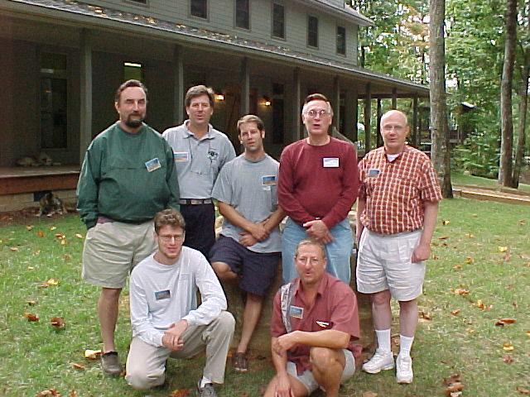 | 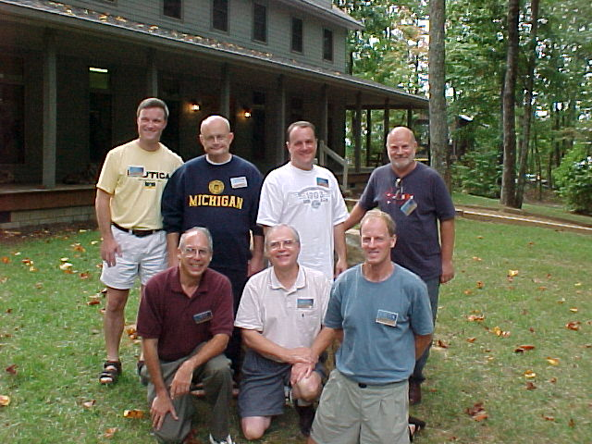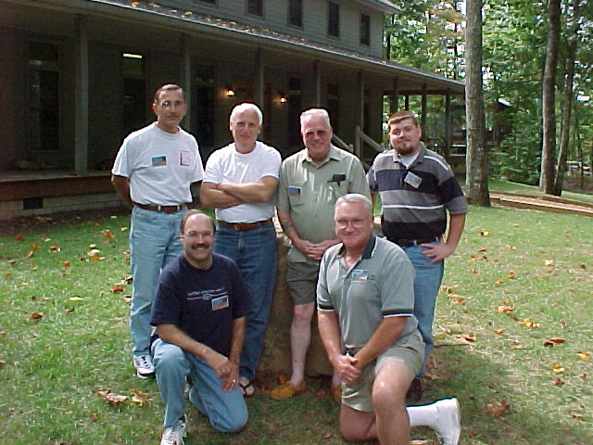
L→R Back Row: Joe MacDonald, Robb Morris, Jeff Riehl, Joe Rummel, Ted Newsom. Front Row: Mike Shanahan, Reid Parish | L→R Back Row: Mike Carlson, Stephen Lanterman, Jim Bello, Jim O'Shanick. Front Row: Tom Hughes, Otto Preske, Xavier Kenworthy
Table of St. Peter
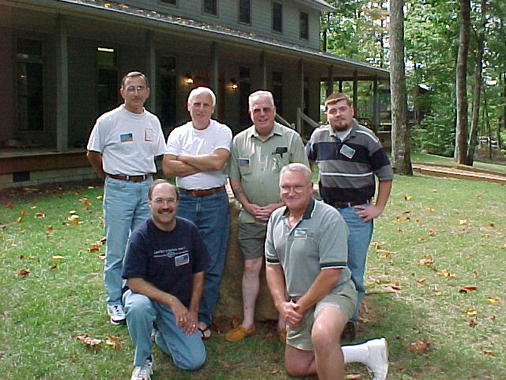 | 
L→R Back Row: Sam Brocato, Steve Pacitti, Jerry Wyatt,
Jason Perry. Front Row: James Prosak, Joe Sonderegger
Diocese of Knoxville – Women’s Cursillo #17
October 10 - 14, 2002 Camp Eagle Rock
Table of St. Therese of Lisieux | Table of St. Faustina
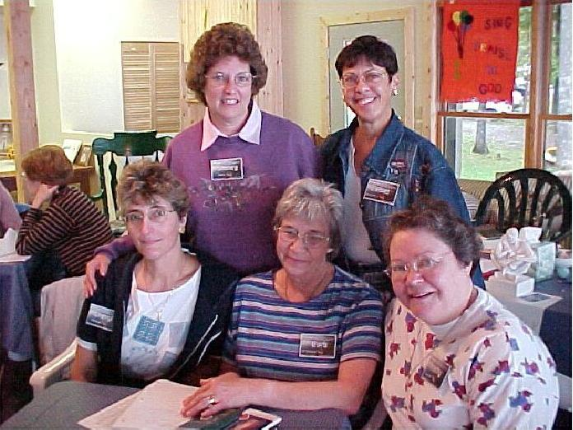 | 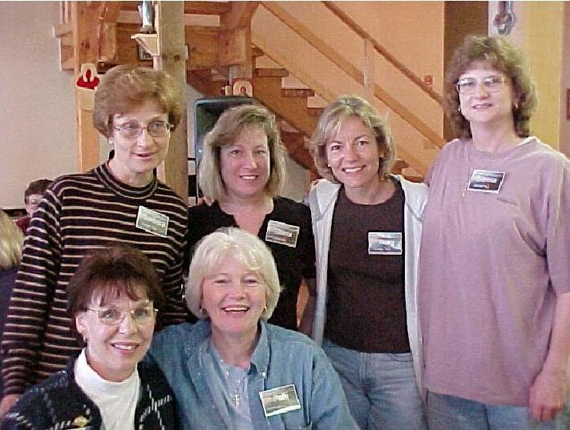
L→R Back Row: Shirley Riehl, Ester Golightly  Front Row: Cheryl Prosak, Barbara Peterson, Kathy DeWine | L→R Back Row: Barbara Lawson, Marla Santodonato, Terry Flynn, Donna Ingram Front Row: Karen Haggett, Patti Morrison
Table of St. Monica | Table of St. Mary Magdalene
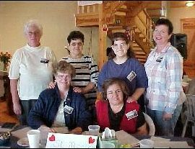 | 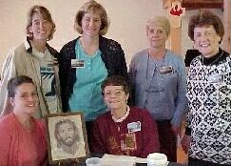
L→R Back Row: Lucy Hughes, Marilyn Hirsch, Kathy Bishop, Rosanne Nichols  Front Row: Lois Schering, Terry Farmer | L→R Back Row: Suzanne Staley, Gail-Marie Walter, Kathleen Caplan, Helga Deveau  Front Row: Nikki Buchanan-Parman, Bobbie Worcester
Table of The Holy Family
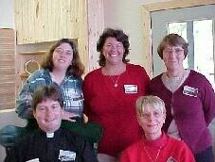
L→R Back Row: Ginger Hutton, Peggy Humphries, Velma Burke
Front Row: Fr. Alex Waraksa, Sharon Brothers

Catholic Cursillo - Diocese of Knoxville

2003 Calendar of Events
All times are Easter - even for events in the Central Time Zone.

Date | Event | Location | Time/Comment
January 11 | School of Leaders  The Three Days | St. Joseph the Worker  Madisonville, TN | 10:00am – 3:00 pm
January 25 | Secretariat Meeting | St. Alphonsus  Crossville, TN | 10:00 am – 3:00 pm
March 15 | School of Leaders  Ultreya! | St. Thomas the Apostle  Lenoir City, TN | 10:00 am – 3:00 pm
April 12 | Secretariat Meeting | St. Jude Catholic Church  Chattanooga, TN | 10:00 am – 3:00 pm
April 24 – 27 | Three Day Weekend #18  Men’s | Camp Lookout  Lookout Mountain, GA
May 2 – 4 | Region IV - Lay and Spiritual Directors Meeting | Camp Marydale  Covington, KY
June 19 – 22 | Three Day Weekend #19  Women’s | St. Therese of Lisieux  Cleveland, TN
July 12 | School of Leaders  Hispanic Spirituality | St. Therese of Lisieux  Cleveland, TN | 10:00am – 3:00 pm
July 17 – 20 | National Encounter | Cincinnati, OH
July 26 | Secretariat Meeting | Our Lady of Fatima  Alcoa, TN | 10:00am – 3:00 pm
September 18 – 21 | Three Day Weekend #20  Men’s | Camp Eagle Rock  Near Maryville, TN
October 4 | Secretariat Meeting | St. Patrick  Morristown, TN | 10:00am – 3:00 pm
October 11 | School of Leaders  Table Leadership | Holy Trinity  Jefferson City, TN | 10:00am – 3:00 pm
October 23 – 26 | Three Day Weekend #21  Women’s | Camp Eagle Rock  Near Maryville, TN
October 24 – 26 | Region IV Fall Encounter | Our Lady of the Snows  Bellview, IL
November 8 | Fourth Day Reunion | To be announced | 11:00 am – 3:00 pm

Catholic Cursillo - Diocese of Knoxville
Applicant Information |  |  |  |  |  |  |  |  |  |  |  | Please return this application to your sponsor with a $10.00 check made payable to Catholic Cursillo - Diocese of Knoxville.
Name: |  |  |  |  |  |  |  |  |  |  |  |  |  |  | Nickname:
 | Last First MI |  |  |  |  |  |  |  |  |  |  |  |  |  |  |  |  |  |  |  | For nametags
Address: |  |  |  |  |  | City: |  |  |  |  |  |  |  |  |  |  |  | State: |  |  |  | Zip
Phone: | ( ) |  |  |  |  |  |  |  |  | e-mail:
Number of Children: |  |  |  |  | Your Age: |  |  |  |  |  |  |  | Occupation:
[ ] Male [ ] Single [ ] Widowed*  [ ] Female [ ] Married [ ] Divorced* |  |  |  |  |  |  |  |  |  |  | *How long? |  |  |  |  |  | Are you a convert? |  |  |  |  |  | If Yes, how long?
 |  |  |  |  |  |  |  |  |  |  |  |  |  |  |  |  | [ ] Yes [ ] No
Home Parish: |  |  |  |  |  |  |  | Location:
In what religious, parish and/or community organizations are you active?
Do you have any physical, medical or dietary conditions that need to be provided for on a weekend?
Applicants Signature: |  |  |  |  |  |  |  |  |  |  |  |  |  |  |  |  | Date:

Sponsor Support |  |  |  |  | Your sponsor will complete the remainder of this application.
Name:
 | Last First MI
Address: |  |  |  |  |  | City: |  |  |  |  |  |  |  | State: |  |  |  |  |  | Zip
Phone: | ( ) |  |  |  |  |  |  | e-mail:
Home Parish: |  |  |  |  |  |  |  |  | Location:
Are you active in Fourth Day activities: [ ] Group Reunion [ ] Ultreya [ ] School of Leaders |  |  |  |  |  |  |  |  |  |  |  |  |  |  |  |  |  |  | If you are not active in any please explain
What is your relationship to the applicant and how long have you known them?
Sponsor comments: (Please include any information that may affect the candidate’s participation in Cursillo)
Please initial the following statements to signify your willingness to be an effective sponsor:
____ I will guide my candidate to a Group Reunion and Ultreya after the Cursillo weekend.
____ I have discussed the Cursillo with my candidate and their attending will not cause any family difficulties.
____ I will bring my candidate to the Cursillo and support him/her through prayer.
Sponsors Signature: |  |  |  |  |  |  |  |  |  |  |  |  | Date:
Pastoral Support
I support the sponsorship of this member of my parish to Cursillo. I know of nothing that will limit their participation.
Pastor's Signature: |  | Date:
All information on this application will be kept in the strictest confidence and must be completed before an applicant can be accepted as a candidate for the Cursillo. The $10.00 application fee is non- refundable.

Catholic Cursillo - Diocese of Knoxville
c/o Butch Feldhaus, Lay Director
5416 Hunter Village Drive
Ooltewah, Tennessee 37363-7004

Forwarding and Correction Requested

To:

The Secretariat
Catholic Cursillo - Diocese of Knoxville
Spiritual Director - Fr. Alex Waraksa
860 Louisville Rd., Alcoa, TN 37701-1838
865/982-3672 awaraksa@hotmail.com
Lay Director - Butch Feldhaus
5416 Hunter Village Drive, Ooltewah, TN 37363-7004
423/238-7009 bfeldhaus@csi.com
Pre-Cursillo - Velma Burke
3697 Miser Station Rd., Louisville, TN 37777
865/983-2812 tenntwo@mindspring.com
Cursillo Weekend - Carol Bolton
3206 Heather Glen Dr., Maryville, TN 37801-8971
865/981-1267 KEOKUKKID@lock-net.com
Post-Cursillo - Susan Passarello
7542 Cherokee Springs Way, Knoxville TN 37919
865/531-6251 qpass@aol.com
School of Leaders - Jim Heath
117 Deer Run Circle, Crossville, TN 38555
931/788-2569 jsheath@charter.net
Treasurer - Debra Ferreri
1321 Parker Ave. SW, Cleveland, TN 37322-2439
423/478-5619 bambilynn2@aol.com
Secretary - Marianne Hartman
179 Dudala Way, Loudon, TN 37774
865/458-0936 mtnest@volfan.net

The Rooster Crows is a publication of the Catholic Cursillo of the Dioceses of Knoxville in Tennessee. The opinions expressed herein are those of the authors and not necessarily those of the Catholic Cursillo of the Diocese of Knoxville in Tennessee, the Catholic Diocese of Knoxville in Tennessee or the greater Cursillo Movement. If you would like to submit an essay for publication consideration, please contact the Lay Director, Butch Feldhaus.

